
% DIFICULTAD | PUNTAJE TOTAL | PUNTAJE OBTENIDO | PORCENTAJE OBTENIDO
60% | 40
COLEGIO PEDRO DE VALDIVIA DE VILLARRICA
Departamento de Inglés
Miss Angélica Arévalo R.
Programa de integración
Rayen Romann
3º y 4º Medio

FORMATIVE TEST UNIT 1 “JOBS AND BUSINESS TIME”
ENGLISH

NAME:
CLASS: |  |  | DATE:
OBJETIVO(S) DE APRENDIZAJE |  | HABILIDADES |  |  | CONTENIDOS
- OA1: Comprender información relevante en textos orales y escritos.  - OA2: Producir escritos claros. |  | -Identifican ideas principales e información explícita.  -Responden preguntas abiertas.  -Usan el discurso indirecto para reportar lo que otros dicen. |  |  | - Vocabulario relacionado con las profesiones y ocupaciones.  -Vocabulario relacionado con el mundo de los negocios.  - Discurso indirecto.

ÍTEM I COMPRENSIÓN AUDITIVA
1. ESCUCHA a las 3 personas hablando de sus trabajos y ASÓCIALAS con la imagen. (____/ 3 pts.)

WRITE the number (1, 2 or 3).

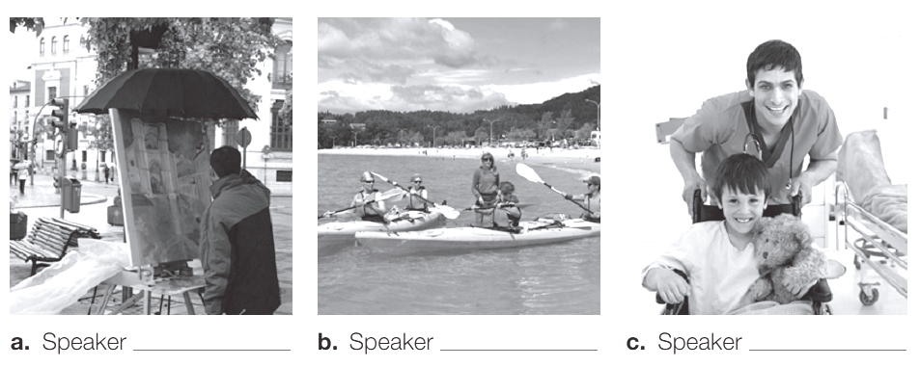

2. ESCUCHA nuevamente e IDENTIFICA quién dice cada enunciado. Speaker 1, Speaker 2 o Speaker 3. (___/ 6 pts.)
a)__________ doesn’t have much work in winter’s time.
b)__________ thinks the salary is poor, but the job will be very satisfying.
c)__________ will sleep very little at night.
d)__________ is happy when people return home.
e)__________ would like to have another job in the future.
f)__________ can wear informal clothes at work.

3. ESCUCHA por última vez y ESCRIBE verdadero (T) o falso (F). (___/ 6 pts.)
a) ________ Speaker I will earn a lot of money.
Speaker I = HABLANTE 1
Speaker II= HABLANTE 2
Speaker III= HABLANTE 3

b) ________Speaker III wants to work indoors in the future.
c) ________Speaker II will live far from work.
d) ________Speaker III always enjoys his work.
e) ________Speaker I thinks salary is a positive aspect of his job

ÍTEM II COMPRENSIÓN LECTORA

1. LEE el texto y DECIDE si los enunciados pertenecen al job I o al Job II. (___/ 6 pts.)

a) ____ allows on-line application. d) _____ pays less than US$10 per hour.
b) ____ is a part-time position. e) _____ provides paid training.
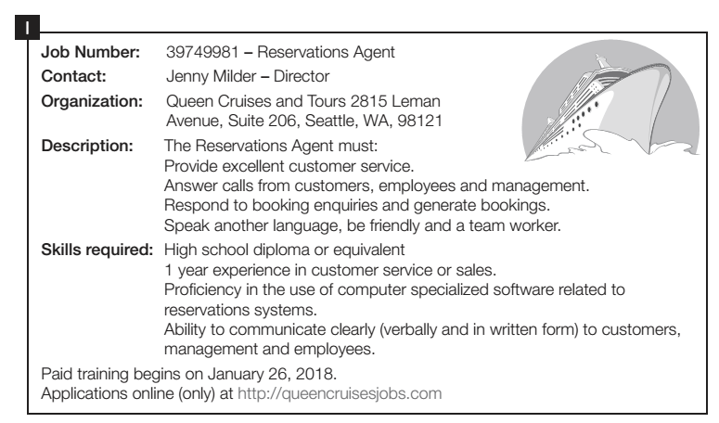
c) ____ is based in Seattle. f) _____ requires previous experience

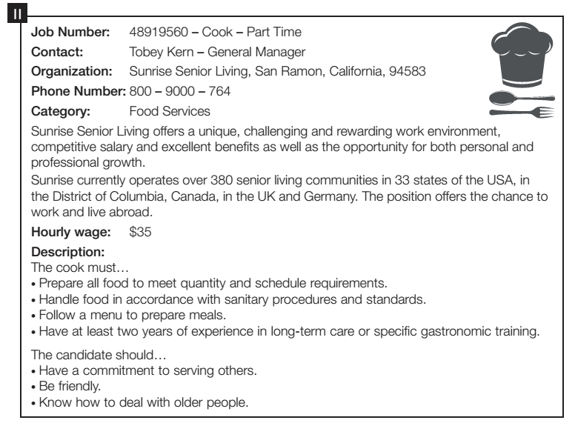

2. LEE nuevamente los textos y RESPONDE las preguntas. (___/ 14 pts.)
What is = Qué es?
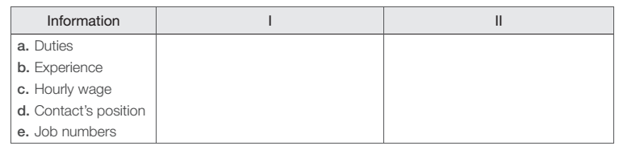
a) What is the type of text?
____________________________________________________________________________
Which job = Qué trabajo?
b) Which job includes receiving and making calls?
____________________________________________________________________________
c) Which characteristics must a person have to apply for job II?
Which characteristics = Que características?
____________________________________________________________________________
d) What must the applicant do for job I?
What must = Qué debe ?
____________________________________________________________________________

e) What must the applicant do for job II?
____________________________________________________________________________
f) What are the social skills you must have to apply for the jobs?
What are= Cuáles son?
____________________________________________________________________________
g) How can you apply for job II?
How can= Cómo puedes?
____________________________________________________________________________
VOCABULARIO:

Working = Trabajando

Playing= Jugando

Says = Dice:

Have = Tener

Skills= Habilidades

Booking = Reserva
VOCABULARIO:

Allows = Permite

Apply = Aplicar

Indoors = Adentro

Challenging = Desafiante.

Answer= Responder

ÍTEM IV USO DE GRAMÁTICA
1. LEE los discursos directos y REESCRÍBELOS usando discurso indirecto. RECUERDA que debes moverte un tiempo atrás. (___/ 5 pts.)

EXAMPLE: SUE SAYS:” I LOVE ANIMALS” SUE SAID THAT SHE LOVED ANIMALS
PRESENT
PAST

a) Maria says: “I am beautiful”.
____________________________________________________________________________
b) John says: “I am playing football.
____________________________________________________________________________
c) I said “I have a smartphone at work”.
____________________________________________________________________________
d) Peter says: · “I love working at the hospital”.
____________________________________________________________________________
e) Sam says: “Camila is a fantastic nurse”.
____________________________________________________________________________

